Mendham Borough Fire Prevention
John A. Zaragoza, Fire Marshal
6 West Main Street
Mendham, NJ 07945
973-543-7152 X *12
firemarshal@mendhamnj.org

Plan Review Report

DATE: December 13, 2022 PLAN REVIEW NUMBER: 22-14

CASE NUMBER: JLUB #23-22

BLOCK NUMBER: 801 LOT(s) NUMBER: 20

APPLICANT NAME: V-Fee Mendham Apartments

In reviewing the plans submitted to my office, I have cause to make the following recommendations at this time. My recommendations shall apply to the project indicated on said plans within Mendham Borough:

- I recommend that the proposed building be outfitted with a full sprinkler suppression and standpipe system as defined by the NFPA 13 and by the NJ Uniform Construction Code. I recommend this system include coverage in all common areas, limited unprotected areas, storage spaces and residential units. Due to the size of the structure, I recommend the placement of multiple standpipes distributed throughout the structure to support firefighter efforts. If this building is equipped with a sprinkler suppression and standpipe system, then the following items are requested/required:

  - A copy of the sprinkler and standpipe installation plans shall be submitted to Mendham Borough Fire Prevention for comment.
  - A copy of all hydraulic sprinkler calculations including documentation of available water supply.
  - All Fire Department Connections shall be fitted with a 2 1/2 inch Siamese Connection as approved.
  - The suppression system shall be monitored by a 24hr fire alarm monitoring company.

- Needed Fire Flow Calculations. There is a strong concern with this Bureau that there will be an adequate amount of water to support firefighting activities within the building located on this site. Typically, water supply is calculated to ensure enough water is available at an appropriate pressure for the fire sprinkler systems to operate properly. Sprinkler designers then add a “hose allowance” based upon the requirements of NFPA 13. This may or may not provide an appropriate amount of water for firefighting operations.

- A certification from New Jersey American Water Company identifying the available water supply prior to construction and post construction shall be submitted to this Bureau for review.

- I recommend that the proposed building be outfitted with a full fire/smoke detection system as defined by the NFPA 72 and by the NJ Uniform Construction Code. If this building is equipped with a fire/smoke detection system, then the following items are required/requested:

  - A copy of the fire detection and alarm system installation plan shall be submitted to this Bureau for comment.
  - I reserve the right to locate any remote annunciator monitoring panels
  - The fire detection system shall be monitored by a 24hr fire alarm monitoring company as indicated on the plans
  - A copy of the NFPA-72 acceptance forms shall be submitted to this Bureau prior to a certificate of occupancy being issued.

- There is a strong concern regarding access to the structure by firefighting apparatus beginning with the entry and driveways to the property. The proposed East driveway is currently consistently obstructed with dumpsters, delivery vehicles, and other storage (See exhibits A, B, C, & D attached). Section 503.1.1 of the 2015 International Fire Code New Jersey Edition states that “The Fire Code Official may require and designate public or private fire lanes as deemed necessary for the efficient and effective operation of fire apparatus, access to building openings by fire fighters or egress of occupants.” Section 503.2.1 states “fire apparatus access roads shall have an unobstructed width of not less than 20 feet (6096 mm), exclusive of shoulders, except for approved security gates in accordance with Section 503.6 and an unobstructed vertical clearance of not less than 13 feet 6 inches (4115 mm). I recommend the establishment of a fire lane with an unobstructed width of not less than 20 feet that encompasses the entire east driveway, east side of building, south side of building, and driveway in-between the building and recreation area.

- In accordance with the Borough of Mendham Ordinance 106-12 through 106-16, I reserve the right to require and approve the following:
A. Signage. In accordance with the current Manual on Uniform Traffic Control Devices, “NO STOPPING OR STANDING” “FIRE LANE” signs shall be erected which designate a fire lane or fire zone.
B. Pavement markings. All painted line delineations shall be four inches in width and shall be applied in accordance with the current Manual or Uniform Traffic Control Devices. The wording shall read “FIRE LANE” and shall also comply with the requirements of the Current Manual on Uniform Traffic Control Devices.

- In accordance with Borough of Mendham Ordinance 62-9, a key box is required to be installed on all structures containing a fire alarm system. I reserve the right to determine the type, manufacturer style and number of boxes to be installed along with their locations. The manufactures original color and texture of the boxes shall be maintained and not compromised.

- I request that I review the location of all proposed exits, equipment access, and storage areas.

- I request that I review and approve the location of the Fire Department Connection and any fire hydrants on the property.

- All fire service equipment rooms and utility rooms in common areas and throughout all structures shall be labeled in accordance with the New Jersey Uniform Fire Code, 2015 International Fire Code, New Jersey Edition.

- All fire exit doors shall be properly labeled in accordance with the New Jersey Uniform Fire Code, 2015 International Fire Code, New Jersey Edition. The exterior of the exit doors shall be labeled as “Fire Door Do Not Block”.

- All work conducted must be permitted and approved by the Mendham Borough Construction Department in accordance with the NJ Uniform Construction Code and any other applicable standards.

Respectfully,

John Zaragoza

John Zaragoza
Fire Marshal

Exhibit A

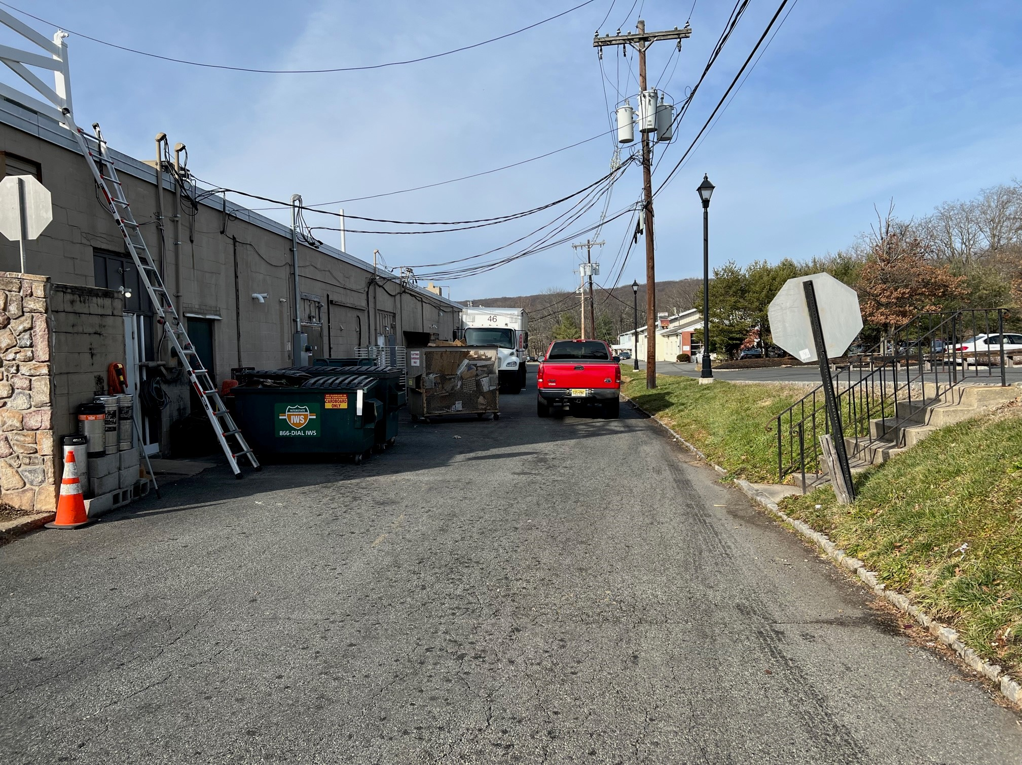

Exhibit B
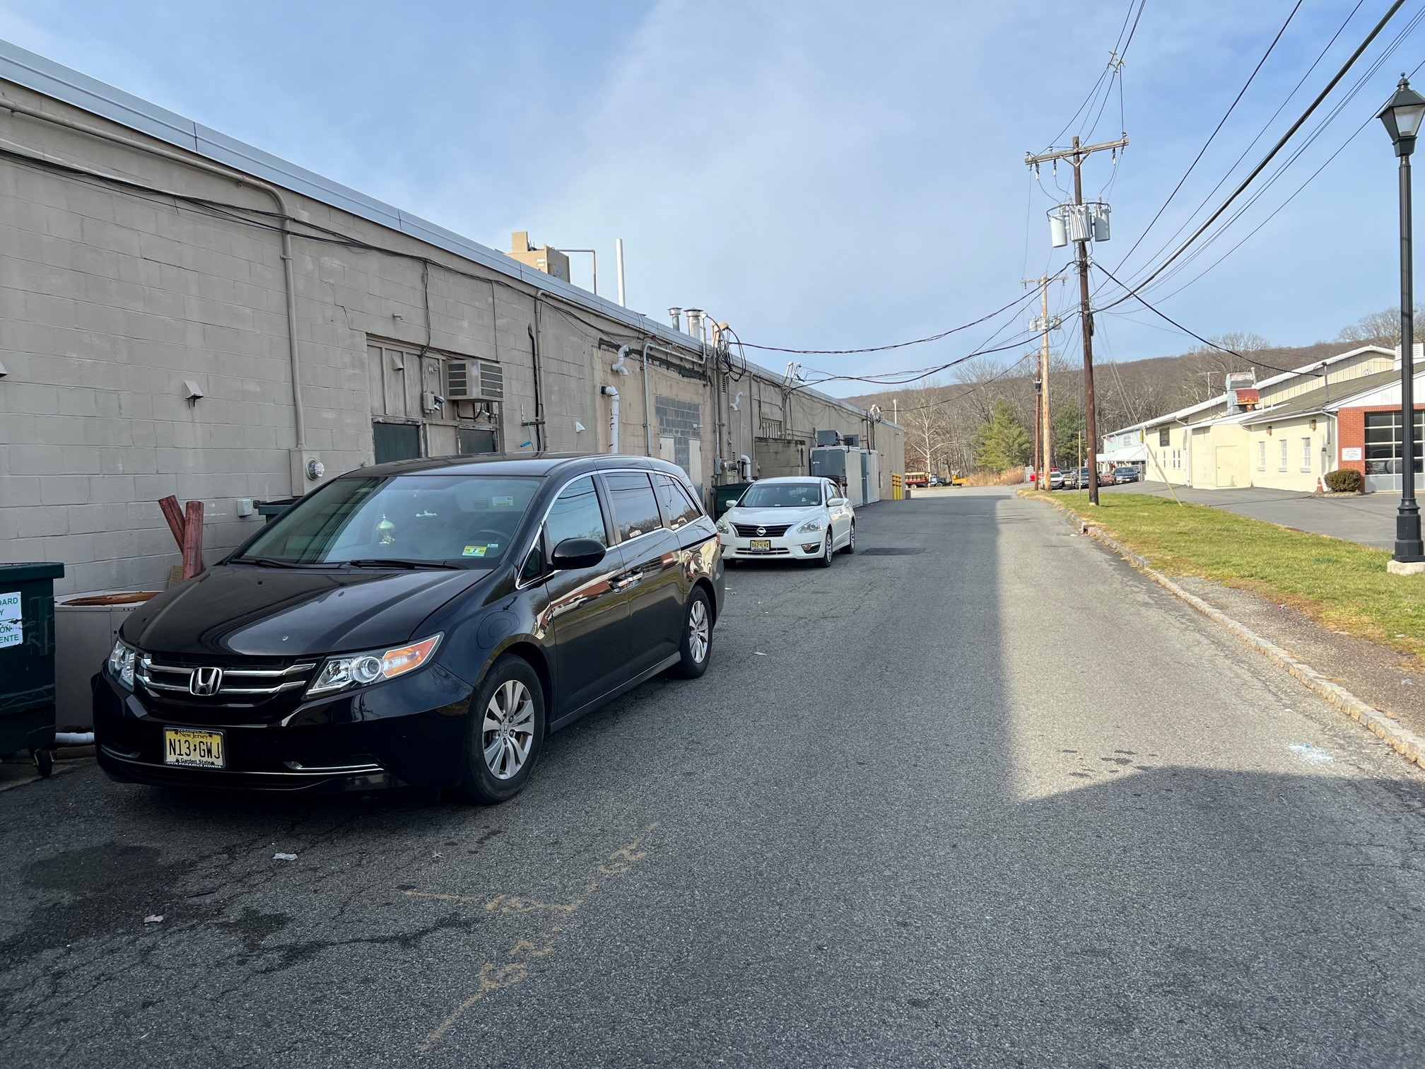

Exhibit C
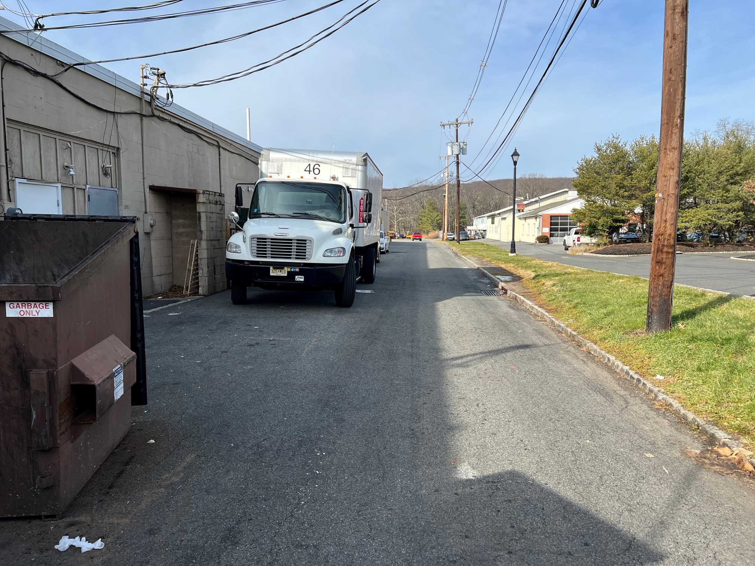

Exhibit D
